**ANGULAR 5 EMAIL & NUMBER PATTERN VALIDATION**

**REF:** <https://www.concretepage.com/angular-2/angular-2-4-email-validation-example>

FIRST YOU HAVE TO SPECIFY A PATTERN STRING,

IN THIS CASE AN EMAIL PATTERN IS:

"[a-z0-9!#$%&'*+/=?^_`{|}~-]+(?:\.[a-z0-9!#$%&'*+/=?^_`{|}~-]+)*@(?:[a-z0-9](?:[a-z0-9-]*[a-z0-9])?\.)+[a-z0-9](?:[a-z0-9-]*[a-z0-9])?"

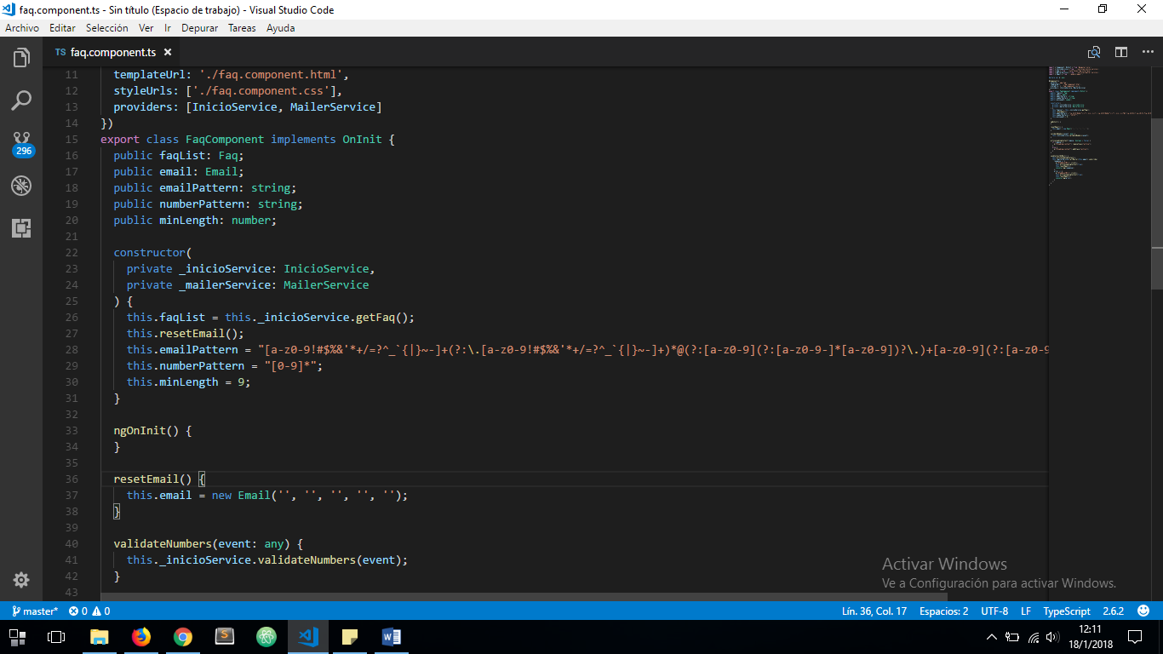

THEN ADD THE PATTERN INSIDE THE TEMPLATE DRIVEN INPUT FORM:

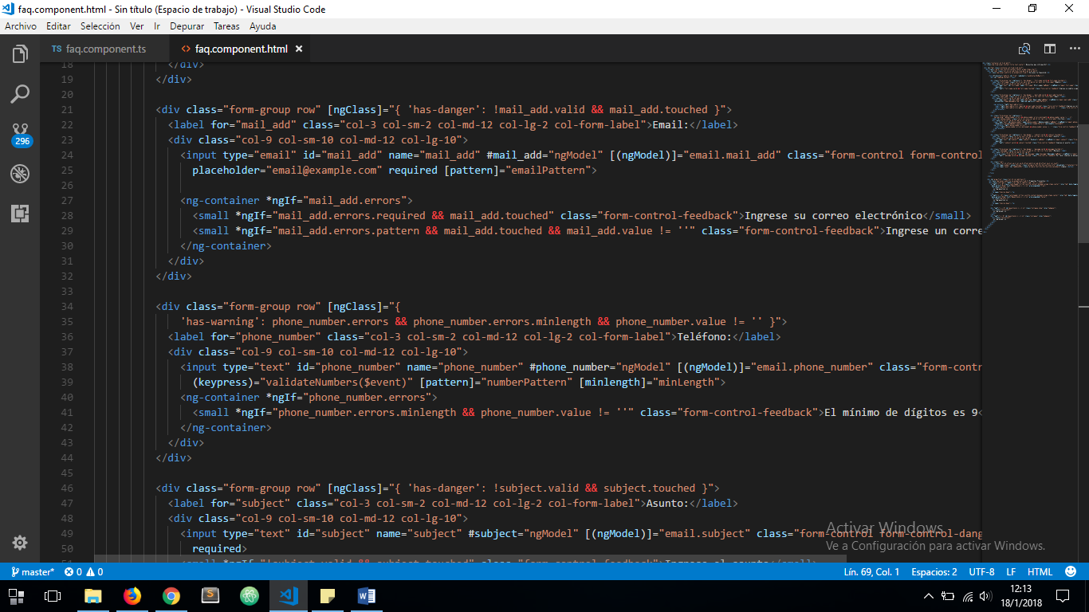

THE RESULT IS:

